Creating or Modifying an Annual Evaluation e-Portfolio

NOTE:
- If you have already created an Annual Evaluation e-Portfolio in a previous year, just use that one and add your material in the appropriate section.
- If you need to add new years to the ePortfolio header, see page 4 of this document.

To create a new e-Portfolio:

- Through the college website, go to e-Portfolios. Login if needed.

- To create a new Annual Evaluation e-Portfolio, click on the Create button.

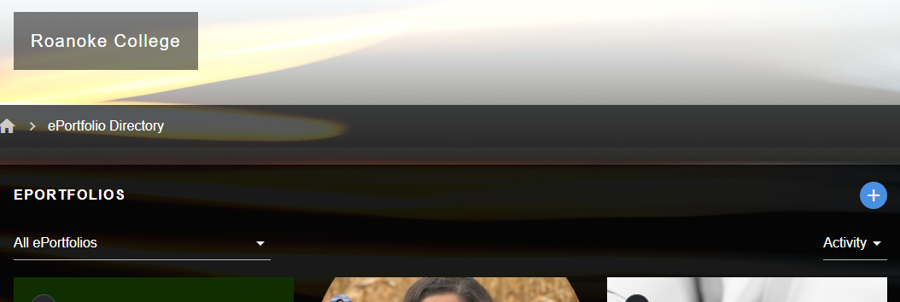

- Choose the “Faculty Annual Evaluation” template.

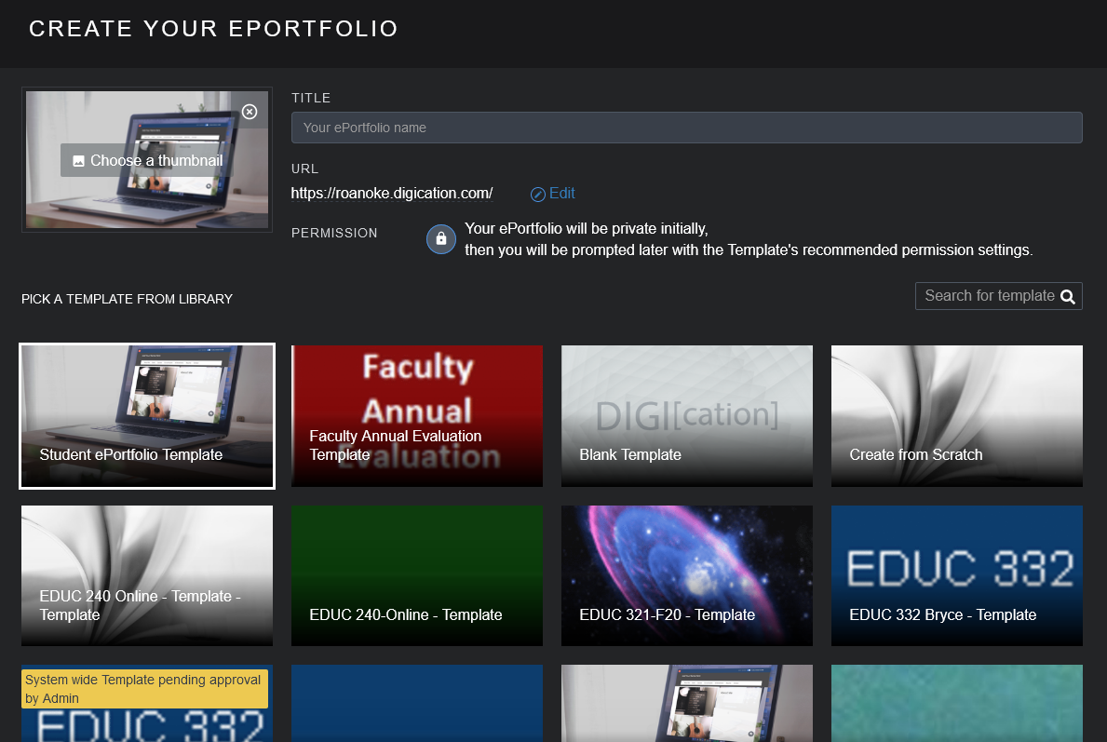

- At the top of the page, name the portfolio something like Joe Blow Annual Evaluation

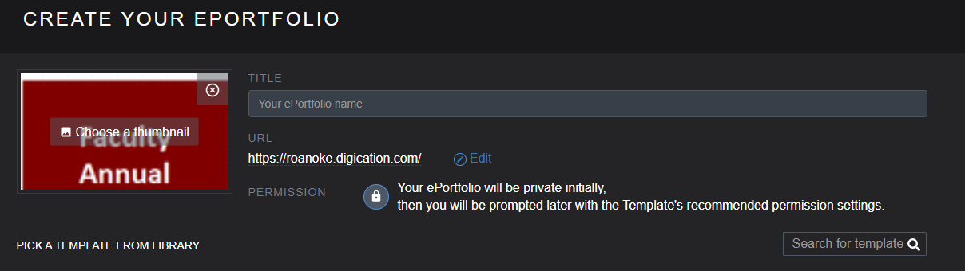

- Click the Create button at the bottom of the screen
- The same portfolio is used year after year, so be sure to choose the right year. Follow directions embedded in the template about what to upload.

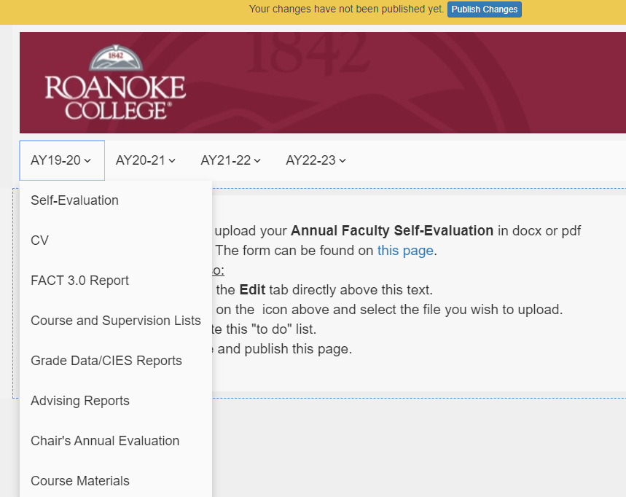

- When you publish, set permissions. Share with your department chair, Richard Smith, Gail Steehler, Richard Grant, David Taylor. Don’t require a password.

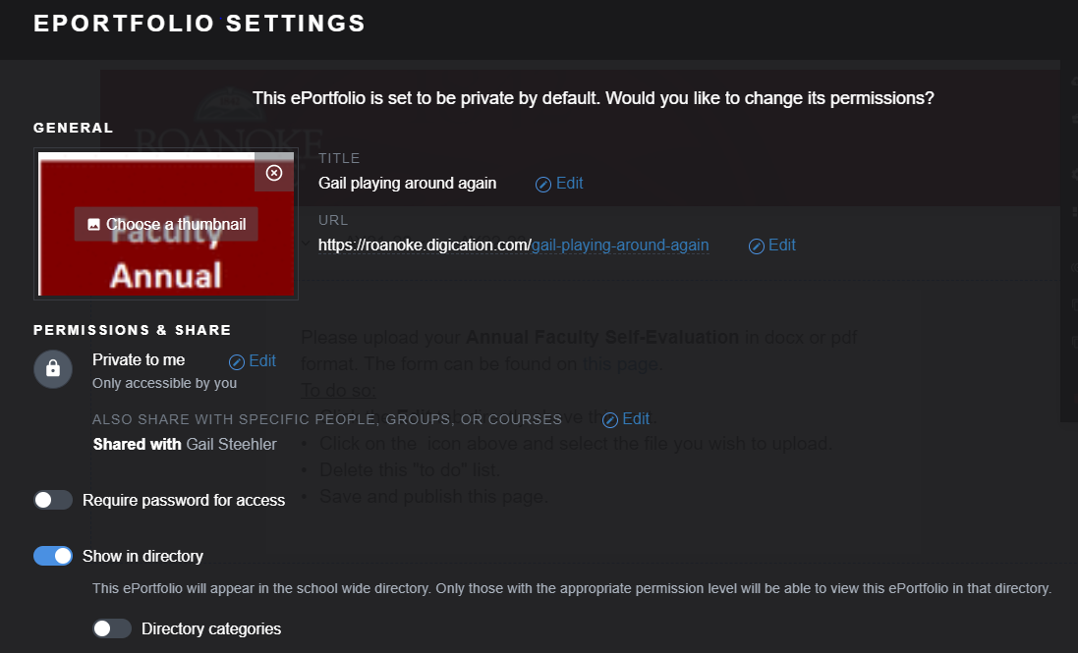

- That’s it! You can now start populating your Annual Evaluation e-Portfolio with the required material. The next time you log into the system you will see your Annual Evaluation e-Portfolio listed under My e-Portfolios. Within the portfolio template, you will find directions and links to needed documents.

Directions for Adding a New Year to your E-Portfolio
Do you need to add a new year to your Self Evaluation e-Portfolio? It is easy to do, once you see the steps.
On the main ePortfolio Page, hover your cursor over the maroon band of the header. A lock symbol will appear in the upper right. Click the lock icon to unlock the headers.
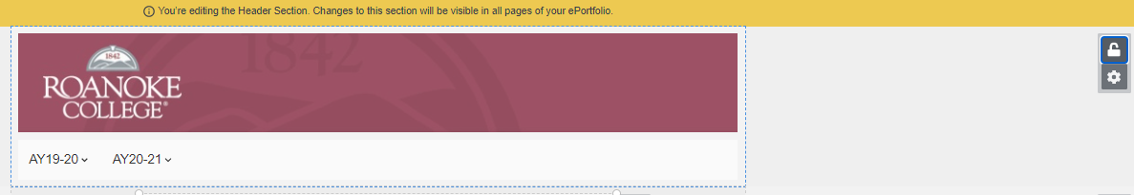

Hover your mouse over the band that shows the years, and choose the “Pencil” icon to edit the pages.
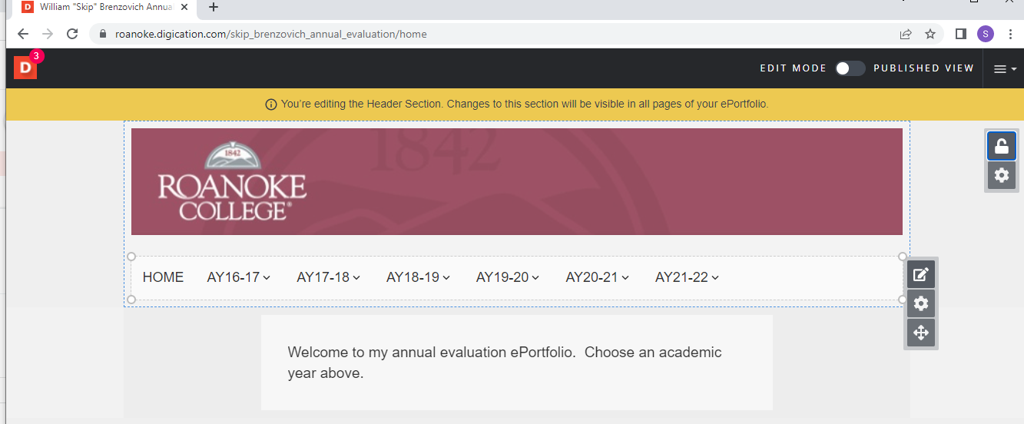
In the newly opened “Page Settings” pane, chose the “Add New Page” button at the bottom of the screen.
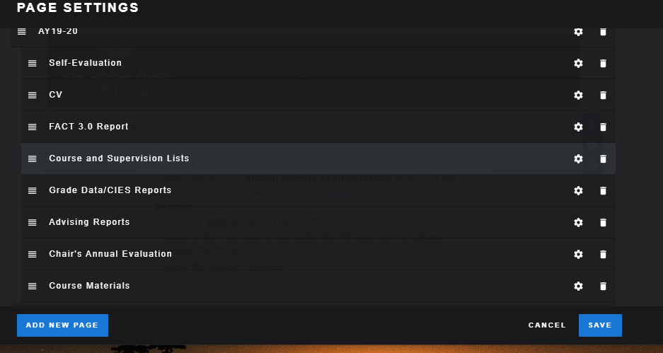

A new page appears in the listing. Label it appropriately in the “Page name” spot. In this example, I need to add AY 21-22, and then all of the sub-pages.
To add the subpage, just click on Add a New Page again. Name it, and then use the symbol to drag the page slightly to the right so that it is indented.
Below is how it looks after I added the AY 21-22 page, then added another page that I labeled Self-Evaluation, and finally used the 3-line hamburger symbol to drag the Self-evaluation page into a slight indent.
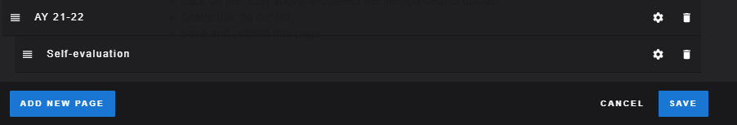

Add all of the required pages that you need. And then be sure to click on Save
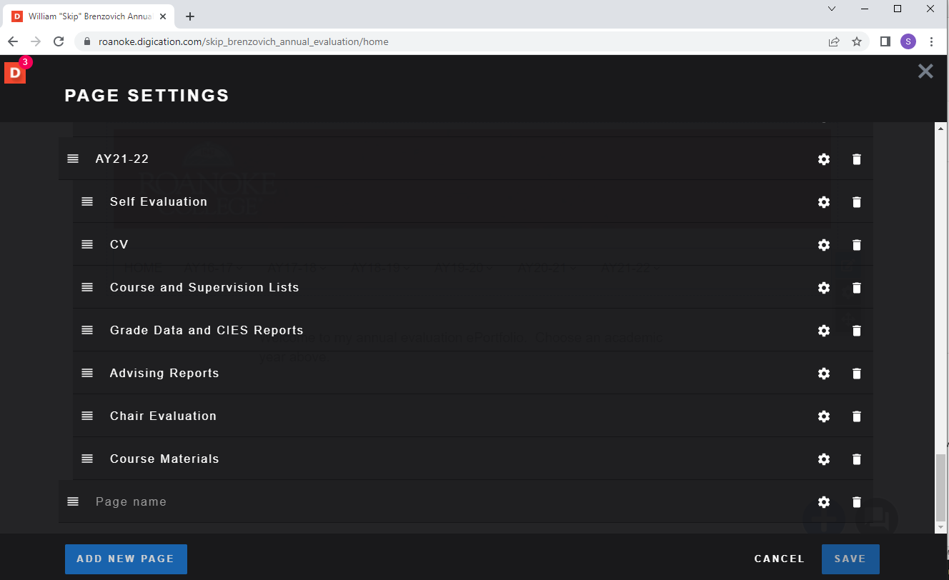
To organize the pages, you can click and drag. Dragging a page to the right makes it a subheading under the page above.

Be sure to click the “Save” button before closing the page to save your changes.

You will see that the new year now shows in your header. If you hover over the year, the subpages you added will also show.

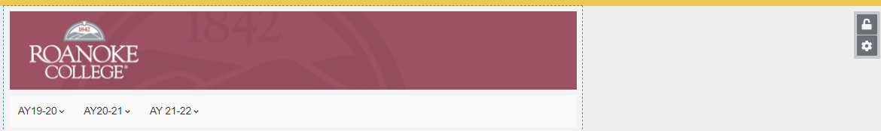

Click on the lock symbol to stop editing the header.

Don’t forget to Publish your e-Portfolio once you are ready to share it with your chair.

