Amanda R. Pickens
Prevention for Deterrence
A Study of Illegal Immigration Policy

Amanda R. Pickens
4/20/2009

Contents
Abstract 3
Methodology 6
Why focus on Mexico? 10
The Labor Debate 11
Legislative History 16
Immigration and Naturalization Act 16
Immigration Reform and Control Act 1986 17
North American Free Trade Agreement 1993 19
Illegal Immigration Reform and Immigrant Responsibility Act of 1996 20
Current Policy 22
Secure Border Initiative of 2005 22
Prevention Initiatives 23
Border Agents 23
Border Fence 24
Technology 25
Analysis 26
Undocumented Citizens 26
Rate of Entry 28
Legal Immigration v. Illegal Immigration Rates 29
Enforcement 30
Conclusion 33
Bibliography 35
Appendix A 38
Appendix B 46

Abstract
Illegal immigration into the United States has drastically increased within the past decades, escalating the concern of American policymakers. In an effort to protect the integrity of the border, the government’s recent theory of offensive is based on the strategy, “prevention through deterrence” (Andreas 2000). This theory increases direct border patrol initiatives including fencing, surveillance, law enforcement personal, and penalties to deter potential crossers from attempting to come into America illegally. While simply increasing border security is not the only justification for the changing illegal immigration trends, this paper suggests it serves as one explanation through evaluation of the development of immigration policy regarding Mexico, review of deterrence initiative programs, and analysis of current statistics.
The issue of illegal immigration is highly debated amongst American citizens. According to Barlett, public opinion polls show Americans overwhelming desire the government crackdown on illegal immigration due to the debate of labor (2006). Many citizens claim the increase of illegal immigration causes economical strains on the government through supplying welfare and increases unemployment rates for Americans. The competing forces, however, argue everyone benefits from the effects of illegal immigration. Companies employ workers with low wages which drives down the costs of products for American consumers. An evaluation of the economical impact shows illegal immigration cost 0.07% of the GDP in 2002.
The year 2007 demonstrates the success of prevention by deterrence reform policy for America through the total number of apprehensions decreasing, total number of removals increasing, total number of border security, fence miles, and technology advances increasing. The number of illegal aliens apprehended at the border is less while border security measures have increased, suggesting the total number of illegal aliens attempting to cross the border decreased over all. Also the supported evidence of a decrease in the total estimated amount of undocumented citizens supported by the Pew Hispanic Center and the Department of Homeland Security supports the philosophy. While certainly these initiatives are not the only explanation for the current decline or leveling of illegal immigration, it does provide one justification. The philosophical policy of prevention by deterrence offers an explanation for the immigration policy trends in the past decade.
Illegal immigration into the United States has drastically increased within the past decade and is highly debated amongst American citizens. According to Barlett, public opinion polls show Americans overwhelming desire the government crackdown on illegal immigration due to the debate of labor (2006). Many citizens claim the increase of illegal immigration causes economical strains on the government through supplying welfare and increases unemployment rates for Americans. The competing forces, however, argue everyone benefits from the effects of illegal immigration. Companies employ workers with low wages, driving down the costs of products for American consumers. The debate drives the public outcry for reform.
In an effort to protect the integrity of the border, the current border control theory of offensive is based on the strategy, “prevention through deterrence” (Andreas 2000). This theory increases the direct border patrol initiatives including fencing, surveillance, law enforcement personal, and penalties for those attempting to cross. The building of these programs inhibits illegal entry of immigrants and eventually avoids apprehensions at the border. The goal of the policy philosophy aims to discourage potential illegal aliens from crossing the border due to the strength of the patrol. The current immigrations policies adopted by Congress embody the prevention through deterrence philosophy by annually increasing border patrol agents, fencing, and technology (Andreas 2000). Through evaluation of the development of immigration policy regarding Mexico, review of deterrence initiative programs, and analysis of currently reported statistics, this immigration policy philosophy of prevention through deterrence provides one explanation for the current immigration trends.

Methodology
In an effort to frame the debate of illegal immigration, I concentrated on one public opinion of its dangers: its economical impact. I relied on public opinion polls published by Gallup authors who conducted telephone surveys of around 2,000 individuals. The poll “Fewer Americans Favor Cutting Back Immigration,” authored by Jones in 2008 highlights public opinion regarding illegal immigrants contribution and their costs. It specifically asks if individuals believe illegal immigrants are taking American worker’s jobs and if they are costs taxpayers more money. Another public opinion survey conducted in 2007 “Americans Have Become More Negative on Impact of Immigrants,” highlights public opinion regarding immigration impact on the economy and job opportunities. These two public opinion surveys allowed me to form a better understanding of the policy debate.
In response to the public opinion regarding illegal immigration, I investigated the actual economical impact of illegal immigration. Most reports and economist I researched agreed illegal immigration has a small positive effect on the economy. Most agree their work force allows employers to hire individuals at a lower wage and increase production providing American citizens with a lower priced consumer product. The employment of these individuals and overall large consumption outweighs the projected economical drain of welfare goods and services provided by the state to illegal immigrants. I focused specifically on a report produced by the Council on Foreign Relations, which is an independent, nonpartisan center investigating current foreign policy initiative. The report compared the fiscal impact of immigrants who would be affected by the currently proposed legislation and based its findings on the National Research Council report and Center for Immigrations Studies reports of 2000. CIS published that in 2002, illegal immigrants received a net income of $10 billion more in benefits from the government than paid in taxes, equally 0.1% of the GDP in 2002. The report compares this to the 5% of the U.S. labor force being illegal immigrants, producing a surplus of 0.03% of the GDP in 2002. These combined numbers estimate a 0.07% of GDP costs of illegal immigration, showing little impact on the economy.
My research regarding the overall number of unauthorized immigration population in America depended on two main sources: Trends in Unauthorized Immigration (Passel 2008) and Estimates of the Unauthorized Immigration Population Residing in the United States (DHS 2008). The Pew Hispanic Center, acting as a sub-branch of the Pew Research Center, is a nonpartisan research center, focusing on the trends of the U.S. Hispanic culture. The Center publishes research on the current demographic, economic, immigration, and labor effects on the Hispanic culture in America. The center is funded by the Pew Charitable Trust based on public charity and donations. Its research is conducted through surveys and analysis of statistics provided by the various governmental bureaus and departments, (Pew 2009). Specifically, the Center’s publications regarding immigration track the number of annually reported foreign born nationals, their characteristics, and effects on population growth (Pew 2009).
The center’s publication as referenced above focuses on the number of estimated unauthorized immigrants over the decade. The Pew Hispanic Center estimates the undocumented population using the “residual method,” a well-developed and widely accepted technique that is based on governmental data. This methodology uses a demographic estimate of the legal foreign-born population—including naturalized citizens, legal permanent residents, temporary legal residents and refugees and subtracts it from the total foreign-born population. The remainder is the estimated population of undocumented citizens. The survey used to gain the total number of foreign born nationals is gathered from the Current Population Survey, which is conducted by the U.S. Bureau of Labor Statistics and the Census Bureau and is a monthly poll of approximately 55,000 United States households. The Center’s estimates are based on the March reference data because each year the survey includes in the March survey additional questions regarding foreign born nationals. The center’s data is therefore adjusted from the government’s publications dependent on the March findings. Due to the center’s dependency on sample surveys, the number used for evaluation is the midpoint range of the margin of error. Those qualifying as an “unauthorized immigrant” include those who are not U.S. citizens, not permanent residents, or do not hold a visa allowing temporary placement in America. The majority of those evaluated are individuals that entered the United States illegally or have remained past their visa’s expiration date (Passel 2008).
The Department of Homeland Security publishes its annual report entitled Estimates of the Unauthorized Immigrant Population Residing in the United States: January 2008, (DHS 2008). This report also utilizes the “residual method,” subtracting the total number of legal resident population from the total foreign born population living in the United States as outline in Table 14. The report gathers the information of legal residence annually from the Department of Homeland Security’s database, while also subtracting the total number of refugees (information gathered from the Department of State) and the number of those granted asylum (information gathered from the Executive Office of Immigration Review of the Department of Justice). Once each of these groups is subtracted from the total number of foreign born nationals, it produces the estimated number of undocumented foreign born nationals. The Department of Homeland Security depends on the survey produced by the American Community Survey, which included a nationwide sample survey to collect information regarding the demographics of the American culture. It is a monthly survey of non overlapping samples with a three million household sample size in 2007. The Department utilized this information instead of the alternative, Current Population Survey, used by the Pew Hispanic Center, because by March 2008 its sample size was only 100,000. The estimates of this report are also subject to interpretation due to the margin of error produced in the ACS surveys (DHS 2008).
My original interpretation of data came from the Department of Homeland Security’s Yearbook of Immigration Statistics. It provides statistics in an Excel spreadsheet, allowing me to create my independent tables and graphs. Upon doing so, I have found data to support the United States concentration on the US-Mexico border for immigration policy, as the majority of illegal immigrants identified each year claim Mexico has their home country. I was also able to draw conclusions regarding the amount of illegal aliens apprehended, returned, and removed each year. Once I cross referenced the public policy initiatives enacted with the facts, I discovered their successful impact.
I also interviewed Christine Poarch, a Salem attorney specializing in illegal immigration. She discussed the local impacts of illegal immigration and provided insight into the relationship between local attorneys, judges, local law enforcement agents, and federal agents. Often her clients are individuals that are living within our community without proper documentation and nationality status, and yet they are able to find employment and become productive individuals. Christine stated individuals within the system are only ever in danger of deportation due to their own actions, whether it be illegally entering the United State or committing a crime, most often driving on a suspended license or without an operator’s license. Being within a small, conservative community, illegal immigration has not carried a heavy weight in the political culture. Its greatest presence is within the court system as later discussed.

Why focus on Mexico?
Immigration policy efforts focus specifically on those illegal individuals from Mexico. The Yearbook of Immigration Statistics, published by the Department of Homeland Security’s Office of Immigration traces the nationality of the illegal aliens identified each year (2007). According to the 2007 statistics, the United States detected a total of 960,756 illegal aliens, of which, 854,261 were from Mexico, as shown in Table 1. Figure 1 presents a bar graph comparing the top five home countries of illegal aliens for 2007. As seen, Mexico accounts for an alarming majority of the individuals detected. Table 2 provides a percentage of classified deportable aliens detected from Mexico during 1999, 2006, and 2007. Highlighting 1999 allows for an interpretation of any trends over the past nine years. A concentration of the past two years, 2006 and 2007, suggests the present large majority of Mexican illegal immigrants. During these three years, Mexico accounted a minimum of 87% of the total number of detectable aliens identified (DHS 1999, 2006, 2007). This data supports the federal government’s concentration on preventing illegal aliens from Mexico. Program implementation focuses directly on the American border as a means to end illegal immigration.
Supporting the findings of the Department of Homeland Security, the Pew Hispanic Center focuses on the importance of federal legislation surrounding Mexico. Trends in Unauthorized Immigration (Passel 2008) reported the population of Mexican immigrants was reportedly 4.8 million in 2000 and rose to 7.0 million in 2008. Referencing Figure 2 and Table 3, the increase of Mexican citizen growth has slowed after 2006, growing approximately 500,000 or less in the past two years, indicating the influence of border security and immigration initiative’s success rates. The center does report that “Immigrants from Mexico account for a majority (59%) of all unauthorized immigrants in the United States,” (Passel 2008) of which, the majority arriving to the United States within the past decade.
The Department of Homeland Security supports the concentration of Mexico by stating “Mexico continued to be the leading source of unauthorized immigration to the United States,” (DHS 2008). Table 4 states of the 11.6 estimated undocumented citizens, 7 million were from Mexico in 2008, making up 61% of the total estimated population. In 2000, Mexicans accounted for 55 % (4.6 million of the estimated 8.46 million) estimated undocumented population, signifying Mexico has continuously accounted for the majority of illegal citizens. This evidence overwhelming supports legislative measures directing attention to the border and immigration enforcement regarding Mexican citizens (DHS 2008).

The Labor Debate
The issue of illegal immigration is highly debated amongst American citizens. According to Barlett, public opinion polls show Americans overwhelming desire the government crackdown on illegal immigration (2006). TIME magazine in 2006 conducted a public opinion poll and discovered 89% of Americans think illegal immigration into the U.S. is a problem while the New York Times’ public opinion poll in 2007 stated 82% of Americans think not enough is being done along the borders to keep illegal immigrants from crossing into the country (FAIR 2009). Many citizens claim the increase of illegal immigration causes economical strains on the government through supplying welfare and increasing unemployment rates for low skilled Americans. The competing forces, however, argue everyone benefits from the effects of illegal immigration. Companies employ workers with low wages which drives down the costs of products for American consumers. The debate of America’s public opinion and actual economical impacts drives the political arena regarding illegal immigration (Barlett 2006, Davidson 2008, Hanson 2008).
TIME magazine’s Barlett assigns some responsibility of illegal immigration to President Bush’s proposal of “a new temporary-work program that will match willing foreign workers with willing American employers when no American can be found to fill the jobs… [The program] will provide a three-year, renewable work visa to the millions of undocumented men and women now employed in the United States.” Barlett claims this message was “widely interpreted to mean that once Mexican citizens cross illegally into the U.S., they would be able to stay and eventually gain permanent residence.” TIME suggests the motivation of most illegal Mexican citizens is to come to America and find employment. The article highlights after speaking with local law enforcement officers on the border, one rancher testified, “All these people say they are coming for the amnesty program. [They] have been told if they get 10 miles off the border, they are home free,” (Barlett 2006). Whether one assigns miscommunication or failure of domestic policies, Mexicans have the impression they may illegally enter the United States to gain employment.
The article also highlights the point of view of many Mexicans. Upon apprehension and proceeding through the removal process, one illegal immigrant stated on his way back to Mexico, “I will be going back [to America] in 15 days. I need to work. The jobs in Mexico don’t pay anything,” (Barlett 2006). While the apprehension and removal rates increase, the mindset of undocumented citizens remains consistent. Mexican citizens are in search for an economic remedy to care for their families; the Mexican economy cannot support their necessary wages and many illegally enter the United States to find employment. In an effort to reduce illegal immigration, policy makers should reduce the reward of entering American territory. To many the solution seems simple: Crackdown on employers. The political arena, however, does not allow for such a drastic motion, (Barlett 2006, Davidson 2008, Hanson 2008).
Most undocumented workers come to America and work in low skill, low wage jobs, specifically in construction, manufacturing, or hospitality. The majority of America workers are not in direct competition for these jobs and “most Americans would notice little difference in their paychecks if illegal immigrants suddenly disappeared from the United States,” (Davidson 2008). Low skilled, low education workers are essential to perform tasks less desirable for the higher percentage of educated individuals. Increased literacy rates and improved education policies have greatly decreased the number of native born residents with less than twelve years of education. From 1960 – 2000, the rate of high school dropouts decreased from 50% to 12%, while in 2000, 74% of Mexico’s population had less than twelve years of education (Hanson 2006). The demand for the low skilled labors remains consistent while the availability of those native born and willing to work in the field decreases. Illegal immigration has the greatest effect on the low educated, low skilled American workers who are in direct employment competition with them. Barlett states, “Washington’s failure to control the nation’s borders has a painful impact on workers at the bottom of the ladder…The system holds down the pay of American workers and rewards the illegals and businesses that hire them,” (Barlett 2006). In fact, economists agree the wages of low skilled workers has decreased 3-8% due to illegal immigration (Davidson 2008). With its growing population, the Mexican economy is unable to provide livable wages for their citizens. They are employed but unable to provide for their growing families; therefore, employment in America seems a viable option, (Barlett 2006, Davidson 2008, Hanson 2008).
Undocumented workers do, however, provide a demand which creates new jobs in America. With an increased population of over 11 million individuals, every day activities of these individuals create a high demand. They are grocery shopping, purchasing cars, getting haircuts, and eating at restaurants which increase the demand for labors to meet these needs. This demand creates jobs in various industries that many native born citizens will perform. Also, increasing the supply of cheap labor allows companies to increase the productivity of their resources. They are able to generate capital at a great rate for a lower cost, allowing for a cheaper product to the American consumer. Companies employ workers with low wages which drives down the costs of products for American consumers (Barlett 2006, Davidson 2008, Hanson 2008).
Public opinion regarding illegal immigration drives the debate for Washington. Published in the 2008 Gallup opinion poll, individuals were asked specifically about their perception of illegal immigration and the economy. The results in 2006, 66% of those polled believed illegal immigration “costs tax payers too much money” compared to the 29% that believed illegal immigrants “pay a fair share of taxes.” In 2008, 63% believed illegal immigrants “cost taxpayers too much” while 31% believe they “pay their fair share” (Jones 2008). The same poll asked about American’s perspective of illegal immigration and employment, finding 74% in 2006 believed “illegal immigrants take jobs Americans do not want” while only 17% believed they were taking jobs Americans wanted. In 2008, the poll showed 79% believed “illegal immigrants were taking jobs Americans do not want” while 15% believed the opposite (Jones 2008). A majority of Americans acknowledge the employment of illegal aliens will not interfere with the same jobs they are pursuing. They recognized those employed illegally in the United States are not actually replacing the opportunity for residents. This poll also concludes Americans believe illegal aliens are consuming welfare goods and services on the legal citizen’s dime. They believe illegal citizens are gaining health care, education, and welfare at a greater rate than the amount they are paying into the system. The public opinion poll determines most Americans attribute the costs of illegal immigration to payment of public goods, not employment replacement.
According to Economic Logic of Illegal Immigration, the overall cost of illegal immigration on the economy is of little influence (Hanson 2008). The production of additional goods and expansion of cultivation yields income for the U.S. economy. The report, relying on the findings of Borjas, a Harvard professor, states, “The annual immigration surplus in the United States appears to be small, equal to about 0.2% of the GDP in 2004,” (Hanson 2008). This suggests the positive effects of illegal immigration. In the net cost benefit analysis, the report compared the fiscal impact of immigrants who would be affected by the currently proposed legislation and based its findings on the National Research Council report and Center for Immigrations Studies reports of 2000. CIS published that in 2002, illegal immigrants received a net income of $10 billion more in benefits from the government than paid in taxes, equaling 0.1% of the GDP in 2002. The report compares this to the 5% of the U.S. labor force being illegal immigrants, producing a surplus of 0.03% of the GDP in 2002. These combined numbers estimate a 0.07% of GDP costs of illegal immigration, showing little impact on the economy. The 0.07% of the GPD in 2002 could be compared to zero due to the reports margin of error and heavy reliance on assumption. This low number suggests illegal immigration has little to no effect on the economy. Therefore, the debate of illegal immigration lies in the political arena. Many Americans call for reform while major companies lobby against adjustments that may jeopardize their work force. The debate remains between contesting sides; public opinion is satisfied through enactment of policies, while corporate America continues to delay the process of implementation (Barlett 2006, Davidson 2008, Hanson 2008).

Legislative History

Immigration and Naturalization Act
Regulation of Mexican immigrations has evolved over the years due to economic opportunity, unemployment, and the ideology of “starting a better life” in American (Andreas 2000, Durand 2004, Long 1996). The year 1964 brought the massive birth of maquiladora plants—a factory that imports materials and equipment from a country to assemble or manufactures goods. These plants import materials on a duty-free, tariff free basis, avoiding extra costs and fines imposed. In response to the booming factory industry, many Americans grew concerned of the rising free flow of goods and people through the border. Many believed the US-Mexico border essentially became blurred and allowed many noncitizens to freely enter the country (Andreas 2000, Durand 2004). As a call for reform and control, the Immigration and Naturalization Act of 1965 amended the previous 1952 Immigration and Nationality Act (INA). Congressman Celler (D-NY) and Senator Hart (D-MI) authored the Immigration and Naturalization Act of 1965 with thirty-two co-sponsors (LeMay 2004) as a result of American citizens concern of a transparent border. Previously, the INA (1952) operated under the US quota system and limited the number of the immigrant population to 2% of the total population, operating under the 1924 Immigration Act. The new amendment considered the importance of reunifying broken families and the desire of American companies for a stronger labor force. The act increased the annual maximum of Eastern Hemisphere immigrants to 170,000 from the previous 2% of the total population (8 U.S.C.§1101, LeMay 2004).
Supporters of the bill denied their opponent’s complaint that the bill would potentially create a new ethnic culture in America and encourage an influx of immigrants. According to Frum, prior to the INA (1965) “immigration law held overall numbers down because it offered almost all the available visas to European countries and Canada where population growth and unemployment rates were low,” (2000). This act reallocated the visas each year and gave preference to families for reunification, thus signaling a rise in non-European visas. Having an influx of new ethnicity did alter the ethnic makeup in American and allowed immigration to double from 1965 to 1970, (Frum 2000). According to Table 5, Figure 3, those apprehended at the border between the years of 1961 to 1971 increased 400%, from in 1961 apprehending 88,823 to 1971 apprehending 420,126 (U.S. Border Fence 1998). Visas were issued for family to reunite and Mexican citizens interpreted it as a calling for new life in America. Many inferred this as an invitation to America and illegal immigration increased greatly. This drastic increase between the ten year span is a result of increased interior efforts to enforce immigration policy. While the rise of apprehensions over the time span remains at a somewhat steady rate, the overall difference in total number over the decade signals a change in culture (U.S. Border Fence 1998).

Immigration Reform and Control Act 1986
During the early 1980’s Americans experienced a rise of unemployment and recession as a primary result of the monetary policy enacted by the Federal Reserve to control inflation. Inflation and unemployment drastically rose as many citizens began to blame the phenomenon on the rise of undocumented aliens in the United States. People affected by the high unemployment rates claimed undocumented citizens were fulfilling possible employment opportunities, (LeMay 2004, Long, 1996). In 1978, Congress created the Select Commission on Immigration and Refuge Policy (SCIRP) committee to study the current effects of immigration on American culture. In March 1981, SCIRP issued its comprehensive report concluding that “immigration was ‘out of control’; that the nation must accept ‘the reality of limitations’ and that ‘a cautious approach’ should be taken in the design of any reform measures,” (Briggs 1991). Specifically the report suggested the United States close the US-Mexico border for undocumented aliens and reexamines its political goals. It stated if the government wanted to reunite families they should export missing family members back to their home countries, and begin to enforce existing laws regarding employer sanctions, increase law enforcement labor, and restructure the immigration policy (Briggs 1991, LeMay 2004).
As a result of heavy lobbying efforts and the political atmosphere, the Immigration Reform and Control Act (IRCA) became active law November 1986. The act made it illegal for private institutions to knowingly hire or recruit illegal immigrants and held employers responsible for the immigration status of all their employees. The act did not retroactively punish those individuals currently undocumented and granted amnesty to those who entered the United States before January 1, 1982 with continuous residency. The act also provided legalization of seasoned workers for those businesses seeking an agricultural labor force. While private businesses decreased their employment of illegal aliens, undocumented citizens could not find employment, resulting in fewer individuals attempting to cross the border. According to Table 5, Figure 3, following the 1986 enactment, apprehensions at the border dropped by 600,000 individuals, 1986 having 1,767,400 apprehended citizens while the following three years saw a decrease to 1,190,488 (1987), 1,008,145 (1988), and 954,243 (1989). The IRCA corrected the fundamental flaw of employing illegal citizens by mandating their documents be verified (U.S. Border 1998). This correction joined with a greater effort of the interior enforcement and border patrol on the local level, explains the significant reduction in apprehension following 1986 (Long 1996, LeMay 2004, CBO 2006). The act failed partially due to the difficulty of enforcement. Employers were held responsible for determining the immigration status of their employees, which includes simply reviewing the documents to their discretion. Hanson summarizes the discrepancy “employers are required to ask prospective employees for proof of employment eligibility. As long as they proffered documentation which appears legitimate, an employer is plausibly able to deny having knowingly hired any illegal alien,” This allows for indiscretion and inconsistency of holding employers responsible and the continued efforts to employ illegal citizens continues (Hanson 2008).

North American Free Trade Agreement 1993
With an increased foreign trade between the U.S. and its bordering nations, the North American Free Trade Agreement (NAFTA) became affective in 1993. The agreement eliminated tariffs on imports and exports of goods between the three countries and eliminated quotas. NAFTA allowed the agricultural trade between the United States and Mexico to spike and open a free market trade of goods. One of the primary goals of NAFTA was to create an economically attractive employment market in Mexico, creating jobs and encouraging citizens to pursue a future in their home country (LeMay 2004). While little direct result can be shown regarding a decrease in undocumented citizens after the enactment of NAFTA, some relation may exist in the amount of returns. A “return” of an illegal citizen indicates when an individual is in violation of immigration laws they voluntarily, without court proceeding, return to their home country. If they decide to return, they are given an opportunity to later revisit the United States legally, without being labeled as “removed.” According to Table 6, Figure 4 (DHS 2008), the number of returned undocumented citizens in 1994 of 1,029,107 increased 65% in two years, 1,573,428 by 1996. NAFTA encouraged the building of open business markets between the two countries and stimulated the border region development of cities and towns. If apprehended at the border, often citizens would simply return home in their emerging border town voluntarily (DHS 2008, LeMay 2004).

Illegal Immigration Reform and Immigrant Responsibility Act of 1996
With the beginnings of the Gulf War and the spike in the cost of oil, early 1990s experienced a recession of increased inflation. This recession resulted in high unemployment, large budgetary deficits and cuts, and a slowed GDP rate of economic growth. Illegal immigration began to become a clear concern for Americans as the recession called for federal budget cuts, specifically r immigration enforcement. Border patrol agents were untrained, over worked, and under funded; reducing their effectiveness and success of preventing foreign nationals from crossing the border (Long 1996, Terraz 2006). As foreign nationals continued their quest into the country, violence rose and border towns were soon overtaken by gangs. The affects of illegal immigration heavily affected Americans as it became increasing clear to the public eye and called for reform.
During Bill Clinton’s reelection campaign in 1996, he purposed a strict approach to decreasing the number of illegal immigrants in the country. In an effort to attract border states and the larger electoral states of Texas and California, Clinton stated he would increase the number of border patrol agents and install 40 miles of a 14 foot fence to deter the flow of immigrants across the border. After his reelection, Clinton signed the Illegal Immigration Reform and Immigrant Responsibility Act of 1996 (IIRIRA) which vastly changed immigration policy regarding the US-Mexico border, specifically the border patrol and interior enforcement agencies. A major revision included increasing powers of local, state, and federal agents for deportation and stricter enforcement along the borders (Durand 2004, Siskind 2008).
The two hundred page act specifically stated border patrol budgeting would be increased to fund new facilities, better training of agents, increase the force by 5,000 agents over the next five years, and allocated $12 million dollars for a 40 mile, 14 foot high, three tiered border fence. The act also enhanced penalties of illegal citizens; previously, one could be deported through the court only if they were sentenced to five or more years incarceration for their criminal activity, but with the passage of IIRIRA, those sentenced, whether a misdemeanor or felony, to one year or more would be eligible for deportation. Aliens attempting the cross the border would now be fined $250.00 and sent back to across to Mexico, while those attempting to escape a checkpoint may be sentenced to five years imprisonment. The act redefines the border crossing identification cards, stating it will contain biometric identifiers that will match the fingerprints of the cardholder to the immigrant. Overall, the act increased the ability of agents to inspect, apprehend, detain, and remove undocumented citizens while also increasing penalties (Durand 2004, Siskind 2008).
Immediately following the enactment of the IIRIRA, the overall number of deportable foreign nationals and removals by federal agents drastically increased. Table 7 and Figure 5 identify the total number of deportable illegal aliens apprehended in the United States over the past seventeen years, (DHS 2007). In 1995 the total number of deportable aliens was 1,394,554 which increased 76% five years later after the passage of IIRIRA to 1,814,729 in 2000. In 1997, as mandated by IIRIRA, an expedited removal process was introduced that applied to illegal aliens attempting to enter the United States (CBO 2004). A concentration on border patrol stopped many aliens from entering by increased investigation of fraudulent documentation and improper identification. The United States Citizenship and Immigration Services (USCIS) stated the number of arrests made along the US-Mexico border during this time accounted for over 98% of all apprehensions border patrol made (CBO 2004). It is also important to note, the total number of removals between 1996, having 69,680 removed increased by 40% in 2000, having 188,467, total removed illegal citizens. The introduction of an expedited system and concentration of border patrol with the enactment of IIRIRA greatly impacted the success of lowering the total number of illegal citizens in America (Durand 2004, Siskind 2008).

Current Policy
Referencing Table 7 and Figure 5 indicates immediately following the attacks on September 11, 2001 and decline of apprehensions to roughly 1 million. According to the Congressional Budget Office’s Immigration Policy in the United States, “apprehensions along the U.S. border with Mexico, as compared with other Border Patrol sectors, accounted for the greatest decline in total for the years 2001 through 2003; it is uncertain what factors may have contributed to that decline,” (2004). It is suggested, however, due to the September 11, 2001 attacks, many illegal immigrants may have been deterred from entering the United States, resulting in fewer total removals (CBO 2004). Although apprehension levels were down, immigration policy was still greatly affected during this time.

Secure Border Initiative of 2005
To address the continuous rise of illegal immigration in American and answer the outcry of many Americans the Department of Homeland Security Secretary Michael Chertoff created the Secure Border Initiative (SBI) in 2005. In an effort to reduce illegal immigration and secure the US-Mexico border, SBI introduced a multiyear plan to increase border patrol agents, build a border fence, and increase technology to aid in identifying individuals. The Department of Homeland Security embraced the current “prevention by deterrence” philosophy (Andreas 2000) and to strengthen forces on the border. The goal was to improve the dominance of the border security measure to deter prospective border crossers from attempting to illegally gain entry. The following areas of the SBI are evaluated below on their successes (DHS 2005, 2006).

Prevention Initiatives

Border Agents
As it began in 1924 with the Immigration Act, Congress identified the need for border patrol agents to protect the US-Mexico border. Currently there are over 18,000 Border Agents employed and the Department of Homeland Security states it will increase the number in 2009 by 1,700 additional agents. The primary mission of the agents is to secure the land border shared with Canada and Mexico. The daily duties of the agents include patrolling the border, conducting routine traffic checks, maintaining surveillance of the area, reporting any intelligence leads of immigration issues, and interpreting the physical evidence found during stops. When individuals attempt to enter the United States, it is the primary duty of the agent to be sure they are doing so legally (DHS 2005, 2008, Koumans, 2009, LeMay 2004).
Border Patrol is the law enforcement arm of the U.S. Customs and Border Protection within the Department of Homeland Security. Each agent under goes two months of training and focus on immigration law, naturalization law, Spanish language, and criminal law (DHS 2005). The IIRIRA ordered the total number of agents to double in 1996 by 5,000 over five years. Clinton believed there was a strong need for a force on the forefront of our borders (Siskind 2008). In 2005, the Secure Border Initiative ordered effective integration of border security programs, specifically increasing border enforcement personnel by hiring an additional 1,000 agents. Bush’s Homeland Security Appropriations in 2005 provided an 11% budgetary increase allotted to the U.S. Customs and Border Protection agency, allowing them to rapidly increasing their employers. The Appropriations bill also allotted a 9% increase for Immigration and Customs Enforcement, allowing them to increase the employment of investigators by 250, detention officers by 100, and enforcement agents by 400, (DHS 2005, 2008). By 2006, according to Figure 6, the total number of agents increased 8% from 11,200 to 12,349 total agents and currently there are over 18,000 employed agents (DHS 2006).

Border Fence
Another area of concentration for the SBI was the infrastructure of a permanent fence along the border. Clinton’s IIRIRA allotted $12 million dollars to begin construction on a 40 mile, 14 foot high, triple fence along the US-Mexico border beginning in San Diego (Siskind 2008). In 2005, the SBI purposed completion of the 40 mile fence including increasing the layer, building access roads, and installing adequate lighting for officers to patrol (DHS 2005, 2006). In December 2007, the Consolidated Appropriations Act required the Secretary of the Department of Homeland Security to construct the fence to 700 miles in length. By December 18, 2008, 286 miles of the pedestrian fence and 267 miles of the vehicle fence were completed (DHS 2008).
As highlighted in Table 8, the targeted border miles under effective control rises as the Department of Homeland Security continuously meets its goals. Whether the miles are monitored or actually contain a physical fence, the Department of Homeland Security is fully confident of their successes. Physical fencing is used in areas that are labeled as a “vanishing point,” in which the border between the United States and Mexico is virtually impossible to identify, allowing illegal immigrants easy access into the country (DHS 2008). The vehicle barriers are utilized to focus specifically on drug cartels and smuggling of goods across the border. They are concrete filled steel poles that stand at varying heights to prohibit cars or vans from crossing the border before inspection. One of the main delays of this project is objection from the local landowners who do not desire the fence to be built in their backyard. Their objection has provided some difficulty for the government contractors to conduct surveys of the land and complete their plans of construction. As Secretary Chertoff testified, “the challenge has been that we have been engaged in very particular litigation over a minority but still a significant number of parcels where individuals object to a fence,” (2008). Although the neighbors object to their jurisdiction, Chertoff did state, “all the court challenges to our exercise of authority have ultimately been rejected,” explaining such litigation is simply delaying the project, not stopping it (Chertoff, 2008, DHS 2006, 2008).

Technology
The Secure Border Initiative also encouraged the government to invest in new technology to aid with investigation and patrol. Expanding the budget has allowed DHS to invest in innovative technology for border enforcement. This includes the Unmanned Aerial Vehicles (UAV) developed by Northrop Grumman. The vehicle uses optoelectronic infrared sensors to scan the border looking for individuals attempting to cross illegally. One of the major advantages to the technology is providing a safer work environment for border patrol agents by keeping them away from potentially dangerous individuals. The aircraft is self sustained in flight, requiring no pilot, and contains its own GPS locating system. It has high resolution pictures in both day and night vision and provides clear communication with border patrol agents on the ground. The aircraft can fly at a very high altitude with a quiet engine, making it virtually impossible to detect while in flight. Due to its covert operation, it has successfully identified people attempting to illegally cross the border. The usage of UAVs signifies the future of border patrol through utilizing technology effectively and efficiently. Other technological advances include usage of high speed transportation devices along access road, sensors on the ground, and ground based radar units (Ames, 2004, Kobach 2005, U.S. Border 1998, Wise 2007).

Analysis

Undocumented Citizens
Each year the Pew Hispanic Center and the Department of Homeland Security issue a summary of the current immigration status in America. The studies highlight the current trends, number of undocumented citizens, total apprehensions, and total removals for the fiscal year. As highlighted in the methodology portion, the Pew Hispanic Center’s Trends in Unauthorized Immigration, Undocumented Inflow Now Trails Legal Inflow (Passel 2008) depends upon a monthly survey of 55,000 households conducted by the U.S. Bureau of Labor Statistics and the Census Bureau. In contrast the highlighted Department of Homeland Security’s Estimates of the Unauthorized Immigrant Population Residing in the United States: January 2008 depends on the survey produced by the American Community Survey in 2007, which included a nationwide sample survey to collect information regarding the demographics of the American culture. It is a monthly survey of non overlapping samples and contained a sample size of three million. The Department utilized this information instead of the alternative, Current Population Survey (utilized by the Pew Hispanic Center) because by March 2008 its sample size was only 100,000. While contrasting these two reports, similar trends were discovered (Passel 2008, DHS 2008).
The Pew Hispanic Center’s report highlights a decrease in the number of unauthorized immigrants in 2007, for the first time in the decade stating “the inflow of immigrants who are undocumented fell below that of immigrants who are legal permanent residents. That reverses a trend that began a decade ago,” (Passel 2008). According to Table 9, the Center reported in March 2008, that there were 11.9 undocumented immigrants living in the United States. The range of immigrants regarding the margin of error is from 11.3 – 12.4, providing 11.9 million as the estimated median. In 2007, the range of estimated undocumented immigrants was from 11.9 – 12.9, providing a median range of 12.4 million undocumented immigrants. While dependency on the 11.9 in 2008 to the 12.4 in 2007 is not an exact difference, it does suggest a decreased amount of undocumented citizens overall. The weakness of the survey relies on the margin of error in the findings. The apparent change between the two years is 500,000; this is not enough to determine if in fact a difference existed because the range for each year allows one million as a margin of error. While complete interpretations should not be drawn solely on this one finding, it does compliment the Department of Homeland Security’s research, stating the 2007 year contained less undocumented citizens than the previous year (Passel 2008).
According to Table 10, Figure 6, the Department of Homeland Security estimated a total of 11.6 million undocumented foreign born nationals in January 2008. The report also estimated a decrease in undocumented citizens, similar to the Pew Hispanic Center, from the previous year of 2007 at 11.8 million. It is important to recognize the difference between the 2007 and 2008 years may be a sampling error in the ACS surveys. The estimates could also be impacted by undercounting the foreign born population and the emigration of legal residents. The two numbers do, however, indicate a decrease of undocumented citizens for the present year. This survey also estimates 11.5 million undocumented citizens lived in the United States in 2006, 11.1 million in 2005, and 8.4 million in 2000. The report refers to the Pew Hispanic Center’s findings stating, “The trends reported by DHS are consistent with estimates by the Pew Hispanic Center showing 11.9 million unauthorized immigrants living in the United States in March 2008, 12.4 million in March 2007, 11.5 million in March 2006, and 11.1 million in March 2005 (Passel 2008),” (DHS 2008).
Overall, both sampling surveys do portray an increase of undocumented citizens between the years of 2000 to 2007. The Homeland Security Secretary Chertoff showed optimism when delivering his State of Immigration and the No Match Rule report to the press on October 23, 2008. He commented specifically on the reports, “we (DHS) have, according to Pew, at worst a completely flat rise in immigration meaning no increase, and likely a decrease in the new number of illegal migrants…this is the first year for as long as many of us can remember, there has been no net increase in illegal immigration in this country. In fact, it is likely that there has been a new decrease in the number of illegal immigrants this country,” (Cheroff 2008). Regardless if the findings report a dramatic or minute decrease between the 2007 and 2008 years, it does signal a change of immigration trends, (DHS 2008, Passel 2008).

Rate of Entry
Referencing Table 9 shows a change over the years of undocumented citizens. The report suggests a large portion of undocumented citizens entered at a greater rate during the 2000- 2004 time period than during the 2005-2008 years. The Pew Center suggests the net growth of undocumented citizens slowed in the recent years in comparison to those before. The study suggests the difference between the 2005 rate of 11.1 million to the 2008 rate of 11.9 provides a 275,000 average annual increase. While considering the margin of error, the study estimates an averaged increase of 500,000 over the three year period. In comparison, the study estimates the difference between the 2005 total amount of 11.1 million to the 2000 rate of 8.4 million unauthorized suggests of 525,000 average annual increase of individuals. Upon consideration of the error of assumptions and margin of error the report suggests an average annual rate of 800,000 undocumented individuals (Passel 2008, Pew 2008).
This proves the rate of entering undocumented individuals has significantly decreased over the years. In evaluating the current 11.9 million undocumented citizens, the Center determined the estimated date of arrival into the United States. Referencing Table 11, the study suggested of the 11.9 million, only 13% (1.6 million) arrived in the United States within the recent three years of 2005 – 2008. The study suggests a greater range of 31% (3.7 million) arrived in during the 2000-2004 year supporting the earlier findings of a greater average rate increase during those years. The Department of Homeland Security’s report supports the trends of the Pew Hispanic Center. Table 12 evaluates the date of arrival for the current 11.6 undocumented foreign born nationals. The table states the amount of unauthorized immigrations rose by 37% this decade, specifically during the 2005 – 2007 year span, rising 9%, being 1.07 million, and during the 2000 – 2004 year span, rising 28%, being 3.25 million. This supports the claim of a higher rate of undocumented immigrants entered at the beginning of the century between the 2000 -2004 time span (DHS 2008).

Legal Immigration v. Illegal Immigration Rates
One of the most significant findings of the Pew Hispanic Center report is the rise of legally documented residents surpassed the rise of undocumented citizens for the first time in 2007. Trends in Unauthorized Immigration reported “during the 1998 to 2004 period, the inflow of undocumented immigrants exceeded arrival of legal permanent residents;” as previously discussed the 2005- 2008 estimated annual average entry of undocumented citizens was 500,000, (Passel 2008). The Pew Hispanic Center’s publication states a total of 2.1 legal permanent residents reported during the 2005-2008 time period, suggesting an annual average rate of 700,000, (Passel 2008). Secretary Chertoff commented on this turning point stating, “legal migration is now above illegal migration telling us there is more at work than just the economy… [Quoting Pew] ‘A decade ago newly arrived unauthorized immigrants began to outnumber newly arrived legal permanent resident. The reverse now appears to be true,’” (Chertoff 2008). While the difference in the legally permitted estimated annual rate of 700,000 difference is only slightly greater than undocumented citizen rate entry of 500,000 annually, it does suggest the success of “prevention by deterrence” political philosophy. While we continued to implement prevention measures following the 2005 year, the government lowered the annual total number of attempted individuals significantly, suggesting a future of a higher rate of legally permitted citizens instead of illegal immigration (Chertoff 2008, Passel 2008).

Enforcement
The Department of Homeland Security’s annual report entitled Immigration Enforcement Actions: 2007 highlights the enforcement actions involving foreign nationals including arrests, detainments, returns and removals to measure success rate of their enforcement initiatives. The success of the interior enforcement agents is measured by the number of annual apprehensions and removals. Apprehensions refers to the number of arrests made of illegal citizens, whether at the border or through investigation; removals are those returned to their home country by court order; returns are those who voluntarily departed each year after being caught at the border. Many illegals will prefer to return home to avoid a record of immigration violation. The report states more than 891,000 aliens in 2007 were allowed to return to their home countries without an order of removal, allowing them to possibly later regain access legally into the United States. Of the 891,000 returns, 83% involved Mexican or Canadian aliens who were apprehended at the border by an agent. According to Table 13 of the 960,756 apprehensions, 91% (876,787) were conducted by the Border Patrol programs, and of those carried out by Border Patrol, 98% (858,722 of the 876,787) were on the southwest sectors of the border. This concludes the effectiveness of the Border Patrol programs including agents, technology, and the fence. This indicates the majority of those individuals that are apprehended are discovered upon their attempt to illegally gain entry. It is important to note the total number of Border Patrol apprehensions for 2007, totaling 960,756, decreased by 20% from the 2006 total of the 1,089,136 suggesting a decrease overall in those attempting to cross the border. Border security initiatives, such as border patrol agents hired and completing the fence, have continued to increase over the year as previously discussed. As these initiatives increased, apprehensions decreased suggesting the effectiveness of the policy philosophy of prevention through deterrence. The report also states Mexicans accounted for 89% of the total number of aliens apprehended in 2007, once again affirming the necessity of focusing on Mexican illegal immigration. With the success rates of the Mexican border apprehension and increased border security, the 2007 report suggests the success of prevention through deterrence. Although one may suggest illegal aliens are seeking alternative ways to cross the border, either through smuggling or uncharted geographically locations, some success should be assigned to the border security initiatives, (DHS 2007).
The results presented by the Department of Homeland Security and Pew Hispanic Center reports suggest the success of the legislative initiatives of border patrol, building a fence, and increased interior support. When comparing the number of border patrol agents in Figure 7 (DHS 2006) the number of illegal immigrants apprehended from 2002- 2007, there is a positive correlation of 0.549. As the total number of border agents increases the number of apprehensions increases as well. The positive correlation determines the strength of the linear relationship between the two variables: border agents and apprehensions. While the relationship is not extremely significant, it does show the implementation of border security agents provided the necessary force to obtain more apprehensions. As the Department of Homeland Security employs additional agents the number of arrests of illegal citizens increases accordingly. Following the prevention for deterrence philosophy, the initial years of implementation should allow a positive correlation between those agents employed and apprehensions. The long term goals of the philosophy predict apprehensions will decrease because Mexican citizens will be intimidated and be deterred from crossing the border illegally, (DHS 2006, 2007, 2008, Passel 2008).
More importantly, the relationship between the number of agents and the number of removals in the country from 2001 to 2008 has a positive correlation of 0.937. This strong positive correlation determines there is a direct linear relationship between the number of border agents employed and the number of removals each year. As the Department of Homeland Security increases its border agents and enforcement, the total number of illegal citizens removed from our country rises concurrently. This strong positive correlation suggests there is a direct result of increasing employment of border agents. The beginnings of a removal can be at the border directly, by local police officers participating in the 287 (g) program, or utilizing the local ICE officers. While border patrol agents typical focus on apprehension, they often detain individuals and begin the proceedings of the removal process. By increasing strength at the border, the total number of removals per year increases as well. There is a direct relationship to the number of border agents to those removed. Therefore, the border security measure of employing agents has proven to be a success (DHS 2006, 2008).

Conclusion
According to Andreas, the “border control offense is based on a strategy developed by INC in 1993 called ‘prevention through deterrence’,” (2000). The objective of USCIS is to increase border security and penalitites abundantly to deter potential individuals from attempting to cross the border. During the initial years of implementing border security, the fence, and innovative technology, the total number of apprehensions would ultimately rise enforcing their successes. In following the philosophical path, eventually total number of apprehensions each year would level off and begin to decease because less indidivuals overall would be crossing the border. If the philosophy is successful, after the first several years of implementation, Mexican citizens would witness the improved protection and be deterred from entering. By examining the data presented, this philosophy does in fact seem to be working. During the initial years of implementation after the 1996 passage of IIRIRA, the total number of apprehensions at the border rose between 1994 and 2000 (Table 6). From 2003 to 2007, the total number of apprehensions began to increase exceptionally as the immigration policy called for immediate implementation of increased force on the border (CBO 2004, DHS 2008).
The year 2007 suggests the turnaround and signal of a successful reform policy for America; signaling the effects of prevention for deterrence. The total number of apprehension decreased, the total number of removals increased, and the total number of border security, fence miles, and technology advances increased. Combining these findings suggests the measures are reducing the number of illegal citizens entering the country. Also, the evidence of a decrease in the total estimated amount of undocumented citizens supported by the Pew Hispanic Center and the Department of Homeland Security supports this philosophy. While these measures are not the only explanation for the current decline or leveling of immigration statistics, it does provide support for the current policy. An appropriate recommendation would be to continue with the current policy plan. It seems within the short year span available for evaluation; the programs are successful meeting their goals to protect our borders. Individuals are entering the United States at a slower rate while removals each year continue to strengthen. Further attention should be assigned to the core debate of illegal immigration, their employment. Companies wish to employ workers with low wages, driving down the costs of products for American consumers. Public opinion polls show American want reform and the lobbying efforts of corporations have effectively slowed this process. The philosophical policy of prevention by deterrence can offer an explanation for the immigration policy trends in the past decade, but it has not specifically satisfied the reduction rates requested by the American public at a satisfactory rate (Andreas 2000, DHS 2008, 2007, 2006, Long 1996, Lopez 2008, Passel 2008, Pew 2008, Terrazas 2008).

Bibliography
Ames, Ben. 2004. "Department of Homeland Security uses Northrop Grumman UAV" Military & Aerospace Electronics. <http://mae.pennnet.com/articles/article_display.cfm?article_id=217726> (January 25, 2009).
Andreas, Peter. 2000. Border Games: Policing the U.S. - Mexico Divide. Ithaca: Cornell University.
Appendix A: IMMACT: Provisions and Effects. 2001. San Francisco: University of California-Davis. < http://migration.ucdavis.edu/MN/cir/97report4/Pages217-223/Pages227.htm>
Barlett, Donald L. and James B. Steele. 2006. Who Left the Door Open? New York: TIME Magazine.
Briggs, Vernon M. 1991. Immigration Reform and the Urban Labor Force. Chicago: Cornell University.
Borgas, Jorge. The Labor Demand Curve is Downward Sloping: Reexamining the Impact of Immigration on the Labor Market. Massachusetts: Quarterly Journal of Economics.
Border Security: Barriers Along the U.S. International Border. 2008. Rep. no. RL33659. Congressional Research Reports for the People. 25 Jan. 2009 <http://opencrs.com/document/RL33659>.
Cantwell. 2006. Cantwell Secures Senate Approval to Examine Use of Unmanned Aircraft to Enhance Northern Border Security. Washington: U.S. Senate.
Chertoff, Secretary Michael. 2008. Remarks by Homeland Security Secretary Michael Chertoff on the State of Immigration and the No Match Rule. Washington: Department of Homeland Security.
Congressional Budget Office. 2006. Immigration Policy in the United States. Washington: United State Congress, Congressional Budget Office. 108th Cong., 1st Sess.
Davidson, Adam. 2008. Q & A: Illegal Immigrants and the U.S. Economy. New York: National Public Radio.
Department of Homeland Security. 2008. Budget, Performance, and Financial Snapshot Fiscal Year 2008. Washington: Department of Homeland Security.
Department of Homeland Security. 2008. Citizen’s Report: Fiscal year 2008 Summary of Performance and Financial Results. Washington: Department of Homeland Security.
Department of Homeland Security. 2008. Estimates of the Unauthorized Immigrant Population Residing in the United State: January 2008. Washington: Department of Homeland Security.
Department of Homeland Security. 2009. Fact Sheet: Expansion of US-VISIT Procedures to Additional Travelers. Washington: Department of Homeland Security. <www.dhs.gove/xtrvlsec/programs>
Department of Homeland Security. 2005. Fact Sheet: Secure Border Initiative. Washington: Department of Homeland Security.
Department of Homeland Security. 2006. Goal1: Protect our Nation from Dangerous People. Washington: Department of Homeland Security
Department of Homeland Security. 2007. Immigration Enforcement Actions: 2007. Washington: Department of Homeland Security.
Department of Homeland Security. 2008. 287(g) FOIA Response. Washington: Department of Homeland Security. 1999-2000.
Department of Homeland Security. 1999. Table 55. “Deportable Aliens Located: Fiscal Years of 1892-1999.” Washington: Department of Homeland Security.
Department of Homeland Security. 2006. Yearbook of Immigration Statistics: 2006. Washington: Department of Homeland Security.
Department of Homeland Security. 2007. Yearbook of Immigration Statistics: 2007. Washington: Department of Homeland Security.
Durand, Jorge and Douglas S. Massey, eds. 2004. Crossing the Border: Research from the Mexican Migration Project. New York: Russell Sage Foundation.
Federation for American Immigration Reform. Public Opinion Polls on Immigration. http://www.fairus.org/site/PageServer?pagename=research_researchd74c. November 2008.
Frum, David. 2000. How we got here: the 70's, the decade that brought you modern life (for better or worse). New York: Basic Books.
Garcia, Michael. 1983. Congressional Research Service Immigration Consequences of Criminal Activity. Washington: The Service.
Heer, David M. 1990. Undocumented Mexicans in the United States. USA: Cambridge.
Isidore, Chris. 2006. Illegal Workers: Good for U.S. Economy. CNNMONEY.com
Kobach, Kris W. 2005 July 27. Testimony on “The 287(g) Program: Ensuring the Integrity of America’s Border Security System through Federal-State Partnerships.” U.S. Congress. House Committee on Homeland Security. Subcommittee on Management, Integration, and Oversight.
Koumans, Mark. 2009. Testimony of Deputy Assistant Secretary Mark Koumans, Office of International Affairs, before the House of Appropriations Committee Subcommittee on Homeland Security Appropriations “Secure Border Initiative, Control of Land Border, and DHS Response to Violence on the Border with Mexico. Washington: Department of Homeland Security.
Jones, Jeffrey. 2008. Fewer Americans Favor Cutting Back Immigration. Princeton, N.J.: Gallup.
LeMay, Michael C. 2004. U.S. Immigration. Santa Barbara: ABC-CLIO.
Long, Robert E., ed. 1996. Immigration. Vol. 68. Ser. 1. New York: H.W. Wilson Company.
Lopez, Jorge. 2009. "United States: Effective Date Of E-Verify Federal Contractor Regulation Postponed Until February 20, 2009." Littler: Employment and Labor Law Solutions Worldwide. Mondaq. <http://www.mondaq.com/article.asp?articleid=72524&login=true&nogo=1> ( February 2, 2009).
Lopez, Mark and Susan Minushkin. 2008. 2008 National Survey of Latinos: Hispanics See Their Situation in U.S. Deteriorating; Oppose Key Immigration Enforcement Measures. Washington: Pew Hispanic Center.
Mailman, Stanley. 1995. California Proposition 187 and Its Lessons. New York City: New York Law Journal.
Newport, Frank. 2007. Americans Have Become More Negative on Impact of Immigrants. Princeton N.J.: Gallup.
Passel, Jeffrey and D’Vera Cohn. 2008. Trends in Unauthorized Immigration: Undocumented Inflows Now and Trails Legal Inflows. Washington: Pew Hispanic Center.
Pew Hispanic Center. 2008. A Rising Share: Hispanics and Federal Crimes. Washington: Pew Hispanic Center.
Pew Hispanic Center. 2009. About the Center. Washington: Pew Hispanic Center. <http://pewhispanic.org/about>.
Poarch, Christine. 2009. Personal Interview and Commentary.
Poarch, Christine. 2007. Immigration Law for the Main Street Lawyer. Salem, Virginia: Poarch Law Firm.
Skinner, David and Dr. Louis Nigro. 2006. Illegal Immigration Across the U.S.-Mexico Border. Pennsylvania: U.S. Army War College Strategy Research.
Siskind and Susser. 2008. IIRIRA 96- A Summary of the New Immigration Bill. Memphis: Siskind Susser Bland Law Firm.
Terrazas, Aaron. 2008. “Immigration Enforcement in the United States.” Washington: Migration Policy Institute.
U.S. Border Fence and Patrol Operations. 1998. Washington: Federation for American Immigration Reform. < http://www.fairus.org/site/News2?page=NewArticle&id=16671&security=1601>
United States Code: Section 287 8 United State Code § 1357 Illegal Immigration Reform and Immigrant Responsibility Act. 1996. Public Law 104-208, 104th Cong., 2nd sess. H.R. 3610
United States Code: 8 United States Code §1101: Immigration and Nationality Act. 1952. 82nd Cong., 2nd sess.
U.S. Customs and Border Protection. Department of Homeland Security. 25 Jan. 2009 <http://www.cbp.gov/xp/cgov/home.xml>.
U.S. Immigration and Customs Enforcement. 2008. ICE Access: Agreements of Cooperation in Communities to Enhance Safety and Security. Washington: Department of Homeland Security.
U.S. Immigration and Customs Enforcement. 2007. ICE Access: Fact Sheet. Washington: Department of Homeland Security.
U.S. Immigration Support. 2009. The Patriot Act and US Immigration. Washington: United State Immigration Support.
Wise, Jeff. 2007. "UAVs: No Pilot, No Problem." Popular Mechanics, April Issue.

Appendix A
Table 1
Total | 960,756
Mexico | 854,261
Honduras | 28,263
Guatemala | 23,907
El Salvador | 19,699
South America | 8,672

Table 2
Total Number of Deportable Aliens in relation to
those specifically from Mexico
Year | Category |  | Percentage from Mexico
1999 | Total | 1,714,035
 | Mexico | 1,634,055 | 95.33
2006 | Total | 1,206,457
 | Mexico | 1,057,253 | 87.63
2007 | Total | 960,756
 | Mexico | 854,261 | 88.92

Table 3 (Passel, 2008)
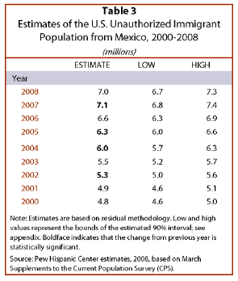
Table 4 (DHS 2008)
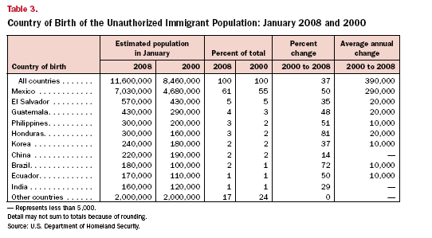

Table 5
INS Apprehension, FY 1961- 1996
Year | Apprehension | Year | Apprehension
1961 | 88823 | 1979 | 1076418
1962 | 92758 | 1980 | 910361
1963 | 88712 | 1981 | 975780
1964 | 86597 | 1982 | 970246
1965 | 110371 | 1983 | 1251357
1966 | 138520 | 1984 | 1246981
1967 | 161608 | 1985 | 1348749
1968 | 212057 | 1986 | 1767400
1969 | 283557 | 1987 | 1190488
1970 | 345353 | 1988 | 1008145
1971 | 420126 | 1989 | 954243
1972 | 505949 | 1990 | 1169939
1973 | 655968 | 1991 | 1197875
1974 | 788145 | 1992 | 1258482
1975 | 766600 | 1993 | 1327259
1976 | 1097739 | 1994 | 1094717
1977 | 1042215 | 1995 | 1394554
1978 | 1057977 | 1996 | 1649986

Table 6
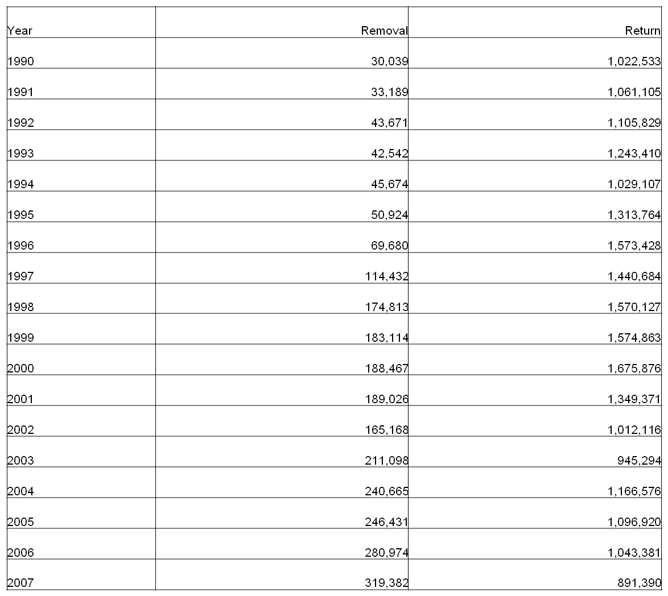

Table 7
1990 | 1,169,939 | 1999 | 1,714,035
1991 | 1,197,875 | 2000 | 1,814,729
1992 | 1,258,481 | 2001 | 1,387,486
1993 | 1,327,261 | 2002 | 1,062,279
1994 | 1,094,719 | 2003 | 1,046,422
1995 | 1,394,554 | 2004 | 1,264,232
1996 | 1,649,986 | 2005 | 1,291,142
1997 | 1,536,520 | 2006 | 1,206,457
1998 | 1,679,439 | 2007 | 960,756

Table 8
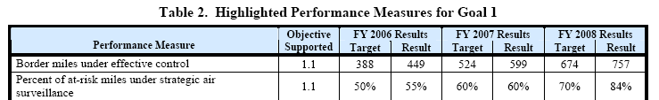

Table 9
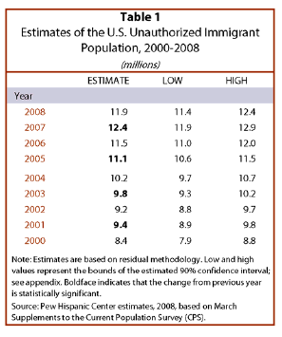
Table 10
Unauthorized Immigrant Population
2000- 2008 DHS Statistics
Year | Millions
2000 | 8.5
2006 | 11.3
2007 | 11.8
2008 | 11.6

Table 11
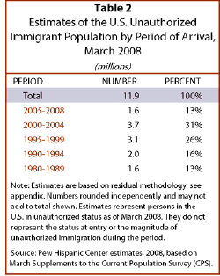
Table 12
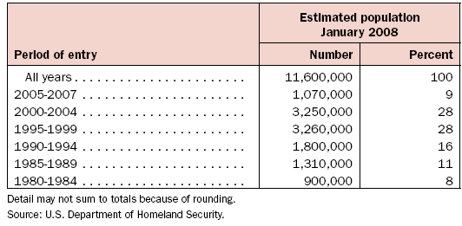

Table 13
Table 14
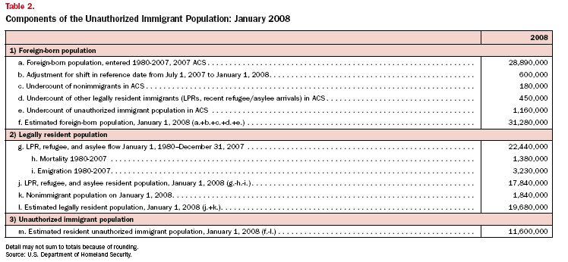

Appendix B
Figure 1
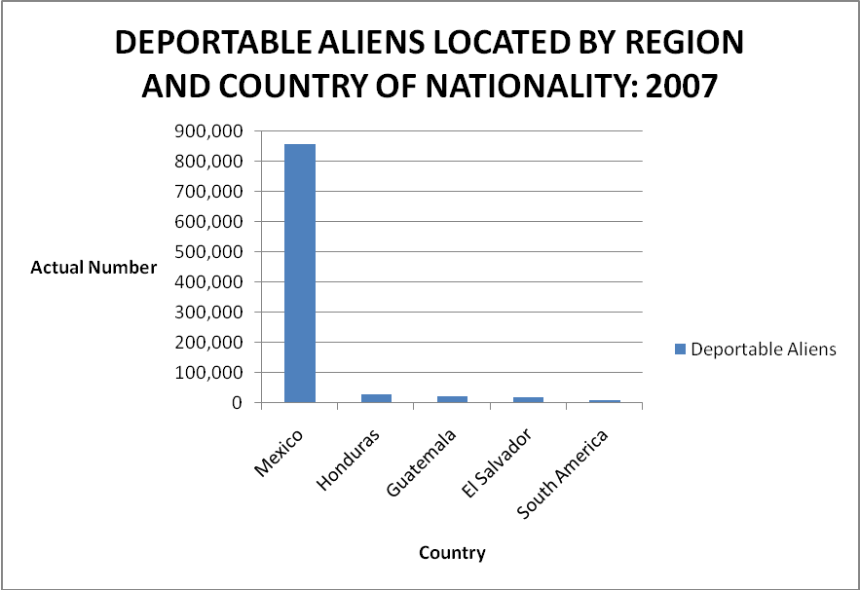
Figure 2
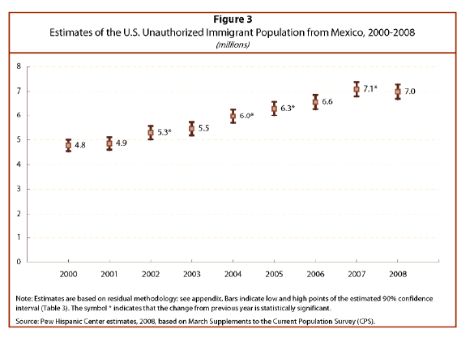
Figure 3
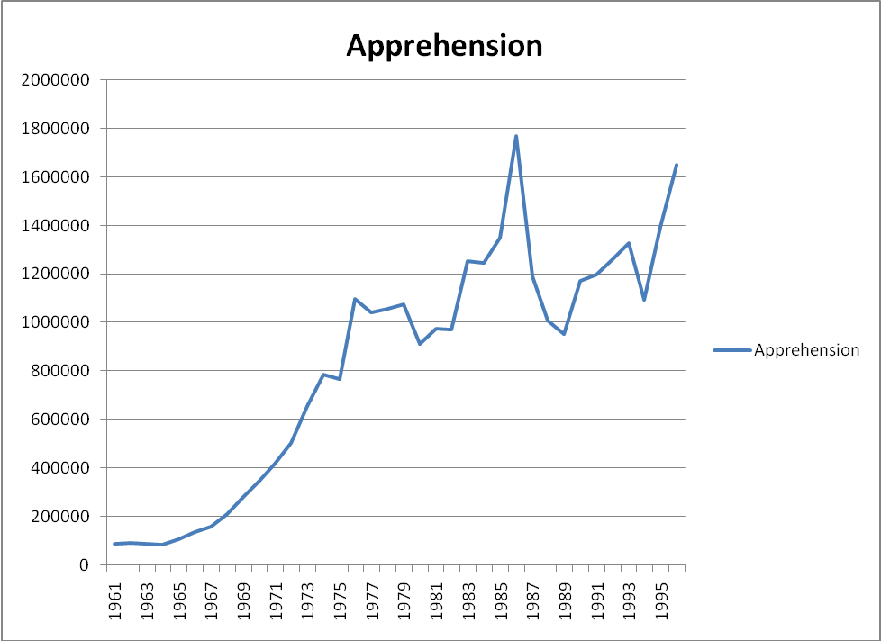

Figure 4
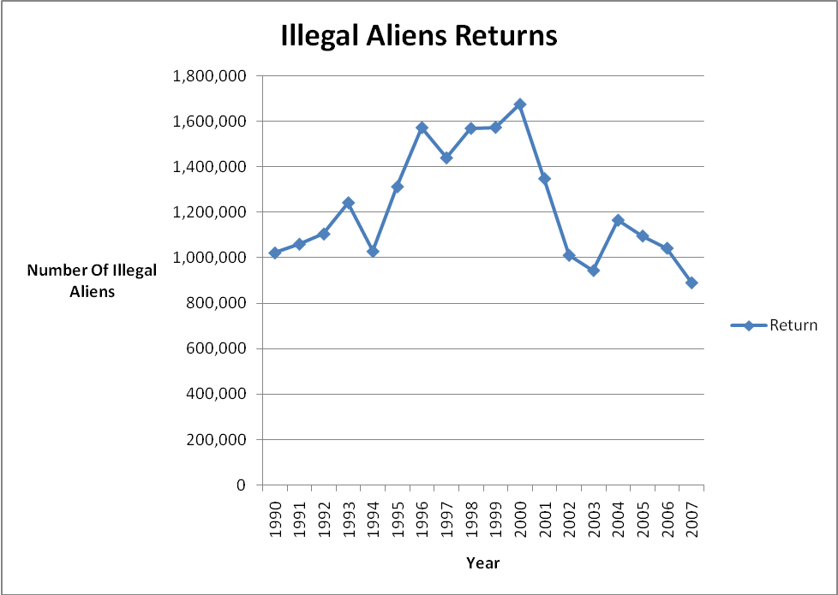

Figure 5
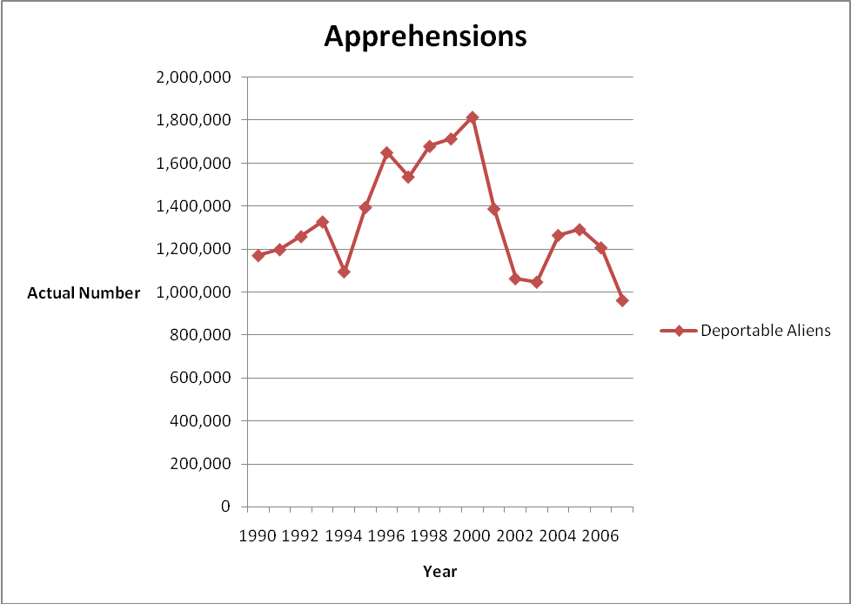
Figure 6
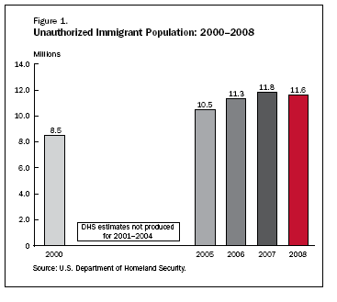

Figure 7
